Information Retrieval — Unit 2 Exam Answers
Exam Unit 2 (Q3/Q4) = Syllabus Unit IV: Text Classification and Text Clustering

Unit Snapshot
No. | Question | Max Marks | Years Asked | Importance
2.1 | Clustering vs classification; can clustering be used for classification? | 6 | N23, M24, N24, N25 | ★★★
2.2 | Types of clustering algorithms; explain any one | 6 | N23, M24, N24, N25 | ★★★
2.3 | Naïve Bayes algorithm & its application in text classification | 6 | N23, M24, N24, N25 | ★★★
2.4 | Agglomerative hierarchical clustering — single link with example | 8 | M24, N24, N25 | ★★★
2.5 | K-Nearest Neighbour classifier with illustration in IR | 6 | N23, N24, N25 | ★★★
2.6 | Mixture of Gaussians model | 5 | N24, N25 | ★★
2.7 | Types of agglomerative clustering | 5 | N23 | ★
2.8 | Hypothesis used in the vector space model for classification | 6 | N23 | ★
2.9 | Partitioning algorithm for clustering | 10 | M24 | ★ (high marks)
N23 = Nov–Dec 2023, M24 = May–Jun 2024, N24 = Nov–Dec 2024, N25 = Nov–Dec 2025. Source file for all citations: Textbooks/IR Sem7.pdf (“PDF p.” = page of the PDF, “§” = section number in the notes).

Must-Do First (★★★)
- 2.1 Clustering vs classification
- 2.2 Types of clustering algorithms
- 2.3 Naïve Bayes for text classification
- 2.4 Single-link agglomerative clustering numerical
- 2.5 KNN classifier in IR
Exam strategy: Q3 (2.1 + 2.2 + 2.3) has been asked unchanged in all four papers. Q4 in N24/N25 = 2.5 + 2.6 + 2.4. Learn 2.9 (K-means) as well — it also answers “explain any one” in 2.2.

Full Answers

2.1 What is the difference between clustering and classification? Can clustering be used for classification purposes? ★★★
Write for: 8 marks (asked max 6) · Asked in: N23 Q3a, M24 Q3a, N24 Q3a, N25 Q3a (all 6 marks) · Source: IR Sem7.pdf, PDF p.23 (§4.2.1 Clustering vs Classification, incl. comparison table)

Definition
- Text classification is a supervised learning task that assigns documents to predefined classes using labelled training data (e.g. spam / not spam).
- Text clustering is an unsupervised learning task that groups similar documents together without predefined labels; documents in the same cluster are more similar to each other than to documents in other clusters.

Difference table
Point | Classification | Clustering
Learning type | Supervised | Unsupervised
Labels / classes | Predefined classes, labelled data needed | No labels; groups discovered from data
Goal | Predict the class of a new document | Group similar documents together
Training phase | Yes — model learned from training set | No training set; works on whole collection
Output | Class label (e.g. Sports, Politics) | Cluster IDs (Cluster 1, 2 …), meaning given later
Number of groups | Fixed by the classes | Chosen by user (k) or found by algorithm
Algorithms | Naïve Bayes, KNN, SVM, decision trees, deep learning | K-means, hierarchical (agglomerative), DBSCAN, EM/GMM
Evaluation | Accuracy, precision, recall, F1, confusion matrix | Purity, silhouette score, intra/inter-cluster distance
Complexity | Needs costly human labelling | Cheaper — no labelling
IR applications | Spam filtering, sentiment analysis, topic categorisation, language identification | Search-result clustering, document organisation, topic discovery, digital libraries
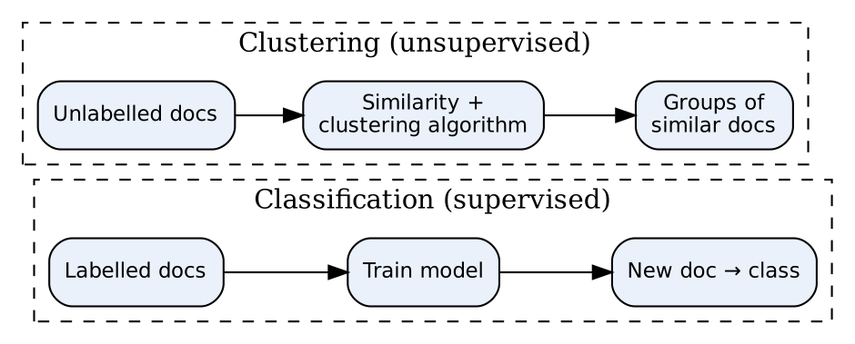
- Classification path: labelled data → trained model → predicts class for new document.
- Clustering path: unlabelled data → similarity (cosine/Euclidean) → natural groups.

Can clustering be used for classification? — Yes
- Cluster-then-label: cluster the documents, then a human labels each cluster (or label by the majority class of the few labelled documents in it); new documents get the label of the nearest cluster centroid.
- Semi-supervised learning: when labels are few, clusters spread labels to unlabelled documents.
- Clusters as features: cluster ID / distance to centroids added as extra features for a classifier.
- Creating training data: clustering finds categories in an unknown collection, which then become classes for a classifier.
- Speed-up: classify only against cluster centroids (like Rocchio) instead of every document.
- Limitation: clusters may not match the real classes, so accuracy is usually lower than true supervised classification.

Example
1,000 news articles with no labels → K-means (k = 3) gives clusters whose top words are {match, goal}, {election, vote}, {stock, market} → named Sports, Politics, Business → new article placed in nearest cluster = classified.

Conclusion
Classification = supervised, predefined labels; clustering = unsupervised, discovered groups; clustering can support classification via cluster-then-label.
Memory trick: “Classification has a Teacher, Clustering has a Crowd”. Write at least 8 rows in the table.

2.2 What are different types of clustering algorithms? Explain any one of them. ★★★
Write for: 8 marks (asked max 6) · Asked in: N23 Q3b [5], M24 Q3b [6], N24 Q3b [5], N25 Q3b [5] · Source: IR Sem7.pdf, PDF p.23–26 (§4.2.2 Partitioning Methods, §4.3 Clustering Algorithms: §4.3.1 K-Means, §4.3.2 Agglomerative Hierarchical, §4.3.3 EM, §4.3.4 Mixture of Gaussians). Density/grid-based types: standard textbook addition.

Definition
A clustering algorithm groups data objects so that intra-cluster similarity is high and inter-cluster similarity is low.

Types of clustering algorithms
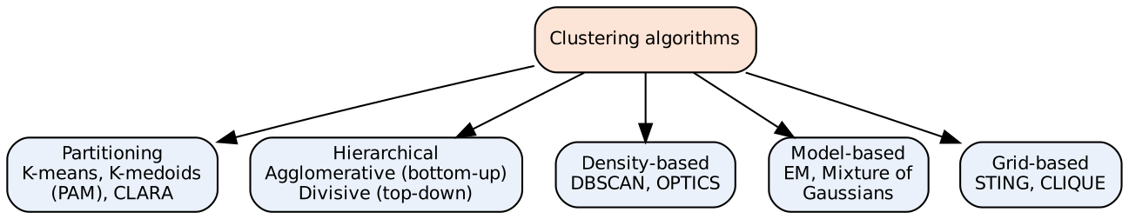
- Partitioning methods: divide N objects into k non-overlapping partitions; each object in exactly one cluster. E.g. K-means, K-medoids (PAM), CLARA.
- Hierarchical methods: build a tree of clusters (dendrogram). Agglomerative = bottom-up merging; Divisive = top-down splitting.
- Density-based methods: clusters = dense regions separated by sparse regions; find arbitrary shapes and noise. E.g. DBSCAN.
- Model-based (probabilistic) methods: assume data comes from a mixture of distributions; soft assignment. E.g. EM, Gaussian Mixture Model.
- Grid-based methods: divide space into a grid of cells; fast. E.g. STING.
- Also: hard vs soft (fuzzy) clustering — hard: one cluster per document; soft: membership probability for every cluster.

Explained: K-Means (a centroid-based partitioning technique)
Input: k (number of clusters), dataset of N objects. Output: k clusters minimising squared error.
- Choose k and randomly select k objects as initial centroids.
- Assign each object to the nearest centroid (Euclidean distance / cosine similarity).
- Recompute each centroid as the mean of its objects.
- Repeat steps 2–3 until centroids do not change (convergence) or max iterations reached.
Objective (squared error): E=i=1kx∈Ci​∥x−mi∥2, where $C_{i}$ = cluster i, $m_{i}$ = its mean.

Example
Points {2, 3, 4, 10, 11, 12, 20, 25, 30}, k = 2 → final clusters {2, 3, 4, 10, 11, 12} (mean 7) and {20, 25, 30} (mean 25). (Full steps in 2.9.)

Advantages / Disadvantages of K-means
- Advantages: simple, fast — O(n·k·t), works well on large document sets.
- Disadvantages: k must be given in advance; sensitive to initial centroids and outliers (K-medoids is more robust); finds only spherical clusters.

Conclusion
Clustering algorithms are mainly partitioning, hierarchical, density, model and grid based; K-means is the most popular partitioning method for text.
Memory trick: “PHD-MG” → Partitioning, Hierarchical, Density, Model, Grid. (“A PhD in Machine Grouping”)

2.3 Explain in detail about Naïve Bayes algorithm and its application in text classification. ★★★
Write for: 8 marks (asked max 6) · Asked in: N23 Q3c “What are the applications of naive Bayes classifier?”, M24 Q3c, N24 Q3c, N25 Q3c (all 6 marks) · Source: IR Sem7.pdf, PDF p.16–17 (§4.1.2 Naïve Bayes Model — Laplace/add-one smoothing, “When to use Naïve Bayes”, applications); spam filtering example PDF p.20–21 (§4.1.4)

Definition
Naïve Bayes (NB) is a probabilistic, supervised classifier based on Bayes’ theorem with the “naïve” assumption that the features (words) are conditionally independent given the class.

1. Bayes’ theorem
$$P\left(cǀd\right)=\frac{P\left(dǀc\right) P\left(c\right)}{P\left(d\right)}$$
- $P\left(cǀd\right)$ = posterior (probability of class c given document d), $P\left(c\right)$ = prior, $P\left(dǀc\right)$ = likelihood, $P\left(d\right)$ = evidence (same for all classes, ignored).

2. Multinomial NB for text
$$c_{map}=arg\max_{c} P\left(c\right)\prod_{k=1}^{n_{d}}{P}\left(t_{k}ǀc\right)$$
- Prior: $P\left(c\right)=N_{c}/N$ (fraction of training docs in class c).
- Likelihood with Laplace (add-one) smoothing: Ptǀc=Tct+1t′​Tct′+ǀVǀ
- $T_{ct}$ = count of term t in class c documents, $ǀVǀ$ = vocabulary size. Smoothing avoids zero probability for unseen words. Use log probabilities to avoid underflow.

3. Algorithm steps
- Pre-process text: tokenise, lowercase, remove stop words, stem.
- Build vocabulary and count terms per class (bag of words / TF).
- Train: compute priors $P\left(c\right)$ and smoothed likelihoods $P\left(tǀc\right)$.
- Classify: for a new document compute $logP\left(c\right)+∑logP\left(t_{k}ǀc\right)$ for each class.
- Assign the class with the highest score.
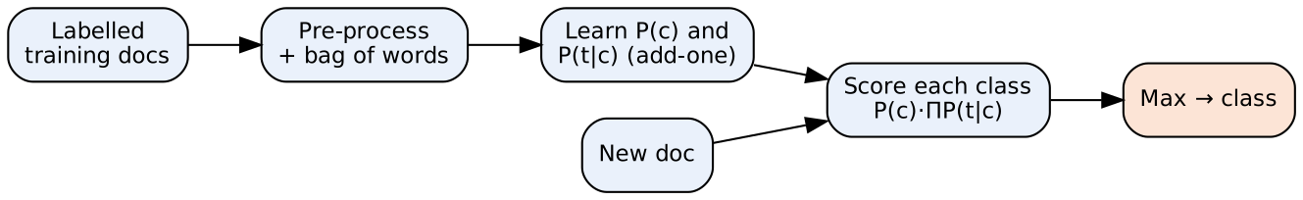
- Training docs → pre-process: convert text to word counts.
- Learn parameters: priors and likelihoods per class.
- Score block: multiplies probabilities for each class; Max chooses the label.

4. Worked example
Training: d1 “Chinese Beijing Chinese” (China), d2 “Chinese Chinese Shanghai” (China), d3 “Chinese Macao” (China), d4 “Tokyo Japan Chinese” (Japan). Test: “Chinese Chinese Chinese Tokyo Japan”. |V| = 6.
- $P\left(China\right)=3/4$, $P\left(Japan\right)=1/4$.
- $P\left(ChineseǀChina\right)=\left(5+1\right)/\left(8+6\right)=3/7$; $P\left(TokyoǀChina\right)=P\left(JapanǀChina\right)=1/14$.
- $P\left(ChineseǀJapan\right)=\left(1+1\right)/\left(3+6\right)=2/9$; $P\left(TokyoǀJapan\right)=P\left(JapanǀJapan\right)=2/9$.
- Score(China) = $3/4×{\left(3/7\right)}^{3}×1/14×1/14≈0.0003$; Score(Japan) = $1/4×{\left(2/9\right)}^{5}≈0.0001$ → China.

5. Applications of Naïve Bayes (text classification)
- Spam filtering (spam / ham) — classic use (notes §4.1.4).
- Sentiment analysis (positive / negative reviews).
- News / topic categorisation, document routing in digital libraries.
- Language identification, intent detection in chatbots.
- Recommendation & real-time prediction (fast), medical text classification.

Advantages / Disadvantages
- Advantages: simple, very fast, needs little training data, works well with high-dimensional text, handles multiple classes.
- Disadvantages: independence assumption is unrealistic; zero-frequency problem (fixed by smoothing); probability estimates are poor (ranking OK).

Conclusion
Naïve Bayes picks the class with maximum posterior $P\left(c\right)∏P\left(tǀc\right)$; despite its naïve assumption it is a strong baseline for spam filtering and text categorisation.
Memory trick: “Prior × Product of Likelihoods → pick Max” (PPM). Never forget +1 / +|V| smoothing.

2.4 Solve Agglomerative hierarchical clustering for single link with example. ★★★
Write for: 10 marks (asked max 8) · Asked in: M24 Q4b [8], N24 Q4c [6], N25 Q4c [6] · Source: IR Sem7.pdf, PDF p.25 (§4.3.2 Agglomerative Hierarchical Clustering — steps 1–7, linkage methods, dendrogram). The worked numerical below is a standard textbook-style example (no solved numerical in notes).

Definition
Agglomerative Hierarchical Clustering (AHC) is a bottom-up method: start with each object as its own cluster and repeatedly merge the two closest clusters until one cluster remains; result is shown as a dendrogram. In single link (nearest neighbour), the distance between two clusters is the minimum distance between any pair of their members:
$$d\left(C_{i},C_{j}\right)=\min_{x∈C_{i}, y∈C_{j}}d\left(x,y\right)$$

Algorithm (notes, Steps 1–7)
- Data representation: convert text to vectors (TF-IDF / bag of words).
- Distance matrix: compute pairwise distances (Euclidean / cosine).
- Initial clusters: each point is a separate cluster.
- Merge closest clusters (smallest value in matrix).
- Update distance matrix using single link (take minimum).
- Repeat steps 4–5 until one cluster (or required k clusters).
- Draw dendrogram and cut at desired height to get clusters.

Worked example
Given: distance matrix of 5 documents A–E.
 | A | B | C | D | E
A | 0 | 2 | 6 | 10 | 9
B | 2 | 0 | 5 | 9 | 8
C | 6 | 5 | 0 | 4 | 5
D | 10 | 9 | 4 | 0 | 3
E | 9 | 8 | 5 | 3 | 0
Step 1: Minimum distance = 2 (A, B) → merge {A,B} at height 2. Update: d(AB, C) = min(6, 5) = 5; d(AB, D) = min(10, 9) = 9; d(AB, E) = min(9, 8) = 8.
 | AB | C | D | E
AB | 0 | 5 | 9 | 8
C | 5 | 0 | 4 | 5
D | 9 | 4 | 0 | 3
E | 8 | 5 | 3 | 0
Step 2: Minimum = 3 (D, E) → merge {D,E} at height 3. Update: d(AB, DE) = min(9, 8) = 8; d(C, DE) = min(4, 5) = 4.
 | AB | C | DE
AB | 0 | 5 | 8
C | 5 | 0 | 4
DE | 8 | 4 | 0
Step 3: Minimum = 4 (C, DE) → merge {C,D,E} at height 4. Update: d(AB, CDE) = min(5, 8) = 5.
Step 4: Merge {A,B} and {C,D,E} at height 5 → single cluster {A,B,C,D,E}. Stop.

Dendrogram
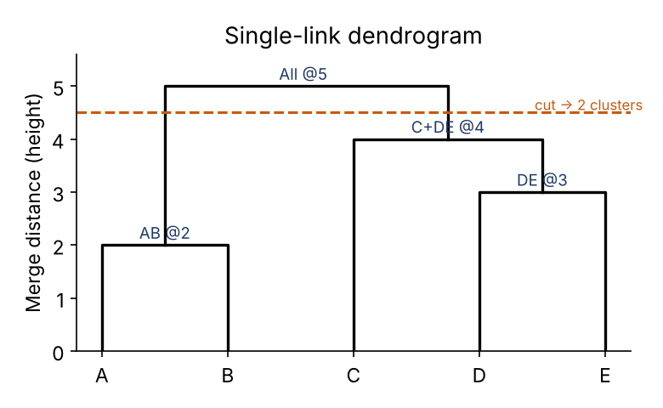
- Leaves (A–E): individual documents.
- Horizontal bars: a merge; height = single-link distance at which clusters merged.
- Dashed cut line: cutting at height 4.5 gives 2 clusters: {A,B} and {C,D,E}.

Final answer
Merge order: {A,B}@2 → {D,E}@3 → {C,D,E}@4 → {A,B,C,D,E}@5. For k = 2: {A,B}, {C,D,E}.

Advantages / Disadvantages of single link
- Advantages: finds non-elliptical / long clusters; simple; no k needed in advance.
- Disadvantages: chaining effect (clusters joined through a chain of close points); sensitive to noise; O(n²) memory.

Conclusion
Single-link AHC repeatedly merges the pair of clusters with the minimum pairwise distance, updating the matrix with min() and recording merges in a dendrogram.
Exam tip: Write “Single link → MIN, Complete link → MAX, Average link → MEAN”. Always redraw the reduced matrix after every merge and finish with the dendrogram — that is where marks are.

2.5 What is K nearest neighbor classifier with an illustration in information retrieval? ★★★
Write for: 8 marks (asked max 6) · Asked in: N23 Q4a, N24 Q4a, N25 Q4a (all 6 marks) · Source: IR Sem7.pdf, PDF p.18–19 (§4.1.3 K-Nearest Neighbor — steps for text classification, distance metrics, choosing k)

Definition
K-Nearest Neighbours (KNN) is a non-parametric, lazy (instance-based) supervised classifier: it stores the training documents and classifies a new document by the majority class of its k nearest neighbours in the feature (vector) space.

Steps (notes)
- Data pre-processing: tokenisation, lowercase, punctuation & stop-word removal.
- Feature extraction: convert documents to vectors — BoW or TF-IDF.
- Distance metric: choose cosine similarity (best for text), Euclidean or Manhattan distance.
- Choose k: a hyperparameter selected by cross-validation (odd k avoids ties).
- Find k nearest neighbours of the test document among training documents.
- Majority voting (or similarity-weighted voting) → predicted class.
Cosine similarity: $cos\left(\vec{q},\vec{d}\right)=\frac{\vec{q}⋅\vec{d}}{ǀ\vec{q}ǀ ǀ\vec{d}ǀ}$
Weighted vote (score for class c): scorec,d=d′∈Skd​Icd′ cosd′,d, where $S_{k}\left(d\right)$ = k nearest neighbours, $I_{c}\left(d′\right)$ = 1 if $d′$ is in class c.

Illustration in IR
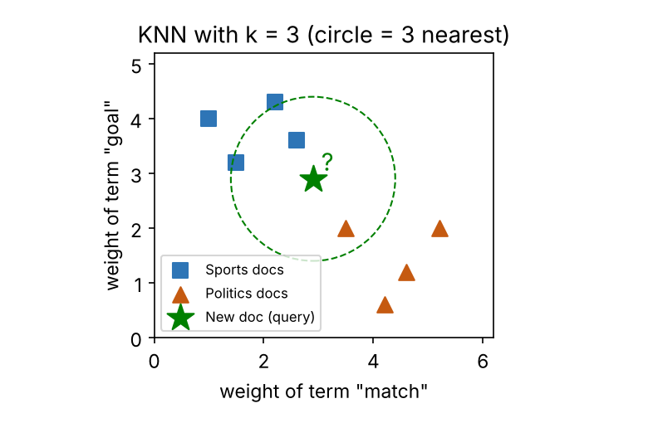
- Squares / triangles: training documents of two classes in TF-IDF space.
- Star: new document to classify.
- Dashed circle: contains its k = 3 nearest neighbours (2 Sports, 1 Politics) → predicted Sports.

Numerical illustration
Cosine similarity of new document d with training documents: D1 (Sports) 0.92, D2 (Sports) 0.85, D3 (Politics) 0.80, D4 (Politics) 0.40, D5 (Sports) 0.35. With k = 3 → D1, D2, D3 → votes Sports 2, Politics 1 → Sports. (Weighted: Sports 1.77 vs Politics 0.80.)

Uses in IR
Document categorisation, spam filtering, recommendation (“users/items like this”), query classification, duplicate detection, image retrieval by similarity.

Advantages / Disadvantages
- Advantages: simple, no training phase, naturally multi-class, works well with enough data.
- Disadvantages: slow at query time (compare with all documents), needs memory, sensitive to k, noise and curse of dimensionality; needs good similarity measure.

Conclusion
KNN classifies a document by voting among its k most similar documents (usually cosine on TF-IDF), making it a simple but effective IR classifier.
Memory trick: “Tell me who your neighbours are, I’ll tell you who you are.” Write: Lazy + Non-parametric + Majority vote.

2.6 Explain Mixture of Gaussians Model. ★★
Write for: 7 marks (asked max 5) · Asked in: N24 Q4b [5], N25 Q4b [5] · Source: IR Sem7.pdf, PDF p.25–26 (§4.3.3 Expectation Maximization, §4.3.4 Mixture of Gaussians Model — steps 1–6)

Definition
A Mixture of Gaussians (MoG) / Gaussian Mixture Model (GMM) is a probabilistic (model-based) clustering method which assumes the data is generated from a mixture of k Gaussian distributions. It gives soft assignment — each point has a probability of belonging to every cluster.

Model formula
px=k=1Kπk Nxǀμk,Σk, k​πk=1
- $π_{k}$ = mixing coefficient (prior of component k), $μ_{k}$ = mean, $Σ_{k}$ = covariance matrix, $N$ = Gaussian density.

Steps (EM algorithm, as in notes)
- Data representation: text → numeric vectors (TF-IDF / BoW, often reduced with SVD).
- Initialise k components: means, covariances, mixing coefficients.
- E-step (Expectation): compute responsibility of each component for each point using Bayes’ theorem: γnk=πk Nxnǀμk,Σkj​πj Nxnǀμj,Σj
- M-step (Maximisation): update parameters using responsibilities as weights: Nk=n​γnk, μk=1Nkn​γnkxn, $π_{k}=N_{k}/N$ (and $Σ_{k}$ similarly).
- Iterate E and M steps.
- Convergence: stop when log-likelihood / parameters change less than a threshold.
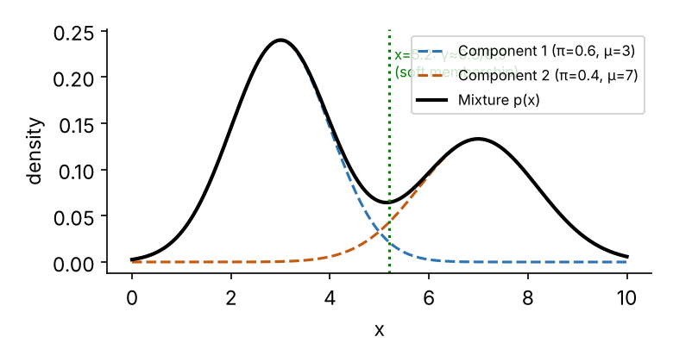
- Dashed curves: individual Gaussian components (clusters) weighted by $π_{k}$.
- Solid curve: overall mixture density p(x).
- Green line: a point between the clusters belongs partly to both (soft clustering).

GMM vs K-means
GMM | K-means
Soft (probabilistic) assignment | Hard assignment
Elliptical clusters (covariance) | Spherical clusters
Learned by EM | Mean update

Applications
Topic/document clustering with overlapping topics, speaker identification in audio retrieval, image segmentation, anomaly detection.

Conclusion
GMM models data as a weighted sum of Gaussians and learns it with EM, giving soft, probabilistic clusters.
Memory trick: “π-μ-Σ” are the three parameters; E = Estimate responsibilities, M = Maximise (update) parameters.

2.7 What are the different types of agglomerative clustering? ★
Write for: 7 marks (asked max 5) · Asked in: N23 Q4b [5] · Source: IR Sem7.pdf, PDF p.25 (§4.3.2 — “linkage methods like single linkage, complete linkage, or average linkage”); formulas and centroid/Ward: standard textbook.

Definition
Agglomerative clustering is bottom-up hierarchical clustering: start with every document as a cluster and merge the two closest clusters repeatedly. Its types differ by the linkage criterion — how the distance between two clusters is measured.

Types (linkage methods)
- Single link (nearest neighbour / MIN): $d\left(A,B\right)=\min_{a∈A,b∈B}d\left(a,b\right)$. Finds long, chained clusters; suffers chaining effect.
- Complete link (farthest neighbour / MAX): $d\left(A,B\right)=\max_{a,b}d\left(a,b\right)$. Gives compact, tight clusters; sensitive to outliers.
- Group-average link (UPGMA / MEAN): dA,B=1ǀAǀǀBǀa∈A​b∈B​da,b. Balance between single and complete; often best for documents.
- Centroid link: distance between cluster centroids $d\left(μ_{A},μ_{B}\right)$. Simple; may give inversions in dendrogram.
- Ward’s method: merge the pair that gives the minimum increase in total within-cluster variance (SSE). Gives equal-sized, spherical clusters (used in notes’ Python code: linkage="ward").
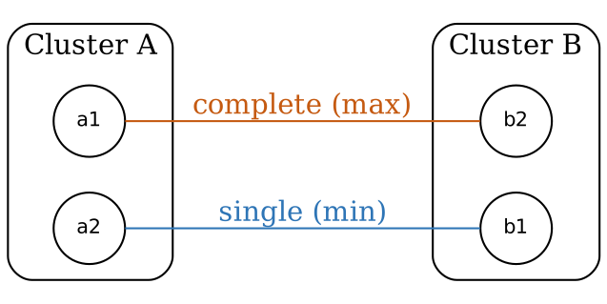
- Cluster A, B: two clusters being compared.
- Blue line (a2–b1): closest pair → single link distance.
- Orange line (a1–b2): farthest pair → complete link distance.
- Average link = mean of all 4 pairs; centroid link = distance between the cluster centres.

Comparison
Linkage | Rule | Cluster shape | Weakness
Single | MIN | Long, chained | Chaining
Complete | MAX | Compact | Outliers
Average | MEAN of all pairs | Moderate | More computation
Centroid | Centre distance | Spherical | Inversions
Ward | Min SSE increase | Equal-size | Assumes spherical

Example
A = {1, 2}, B = {5, 9} (1-D): single = |2 − 5| = 3; complete = |1 − 9| = 8; average = (4 + 8 + 3 + 7)/4 = 5.5; centroid = |1.5 − 7| = 5.5.

Conclusion
Types of agglomerative clustering are defined by linkage: single, complete, average, centroid and Ward; choice of linkage changes the shape of clusters.
Memory trick: “S-C-A-C-W” → “Some Clusters Are Completely Weird”; Single = MIN, Complete = MAX, Average = MEAN.

2.8 What is the hypothesis used in the vector space model for classification? ★
Write for: 8 marks (asked max 6) · Asked in: N23 Q4c [6] · Source: ⚠ Not found in your materials. Standard textbook answer (Manning, Raghavan & Schütze, Introduction to IR, Ch. 14). Related notes: IR Sem7.pdf, PDF p.22–23 (§4.1.6 Vector space classification using hyperplanes and kernel function).

Definition
Vector space classification is based on the Contiguity Hypothesis: “Documents in the same class form a contiguous region in the vector space, and regions of different classes do not overlap.”

1. Explanation
- Each document is a vector of term weights (TF-IDF), normalised to unit length.
- Documents about the same topic use similar words → their vectors lie close together (high cosine similarity).
- Therefore, a classifier only needs to find boundaries between these regions; a new document is labelled by the region it falls in.
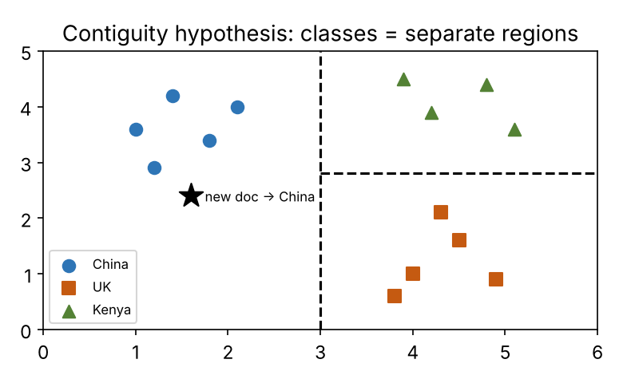
- Coloured groups: documents of three classes occupy separate, contiguous regions.
- Dashed lines: decision boundaries (hyperplanes) learned by the classifier.
- Star: new document falls in the China region → classified China.

2. Classifiers that rely on it
- Rocchio (centroid) classification: class represented by its centroid μc=1ǀDcǀd∈Dc​vd; new document → nearest centroid.
- K-Nearest Neighbour: label from nearby documents in the same region.
- Linear classifiers / SVM: separate regions with hyperplanes $\vec{w}⋅\vec{x}+b=0$; kernel functions handle non-linear boundaries (notes §4.1.6).

3. When the hypothesis fails
- Multimodal classes (one class in several separate regions, e.g. “sports” covering cricket and chess) → Rocchio fails, KNN works better.
- Overlapping vocabulary between classes; poor document representation (e.g. without stemming/TF-IDF).
- Choice of representation matters: weighting and normalisation decide whether contiguity holds.

Example
Documents about “Beijing, Chinese, Shanghai” cluster in one region; “London, Parliament, Britain” in another; a new document “Chinese Olympics in Beijing” lies in the China region → class China.

Conclusion
The contiguity hypothesis — same-class documents form contiguous, non-overlapping regions — justifies Rocchio, KNN and hyperplane-based (SVM) classification in the vector space.
Memory trick: “Birds of a feather flock together in vector space” — Contiguity → Centroid (Rocchio) → Neighbours (KNN) → Hyperplanes (SVM).

2.9 Write partitioning algorithm for clustering. ★
Write for: 12 marks (asked max 10) · Asked in: M24 Q4a [10] · Source: IR Sem7.pdf, PDF p.23–24 (§4.2.2 Partitioning Methods — K-Means, K-Medoids (PAM), CLARA; §4.3.1 K-Means Clustering algorithm with Input/Output and worked example)

Definition
A partitioning method divides a dataset of N objects into k partitions (k ≤ N), where each partition is a cluster, each object belongs to exactly one cluster, and each cluster has at least one object. The number of clusters k is specified by the user. Popular methods (notes): K-Means, K-Medoids (PAM), CLARA.

1. K-Means algorithm (centroid-based technique)
Input: k = number of clusters; D = dataset of N objects. Output: a set of k clusters that minimises the squared-error function.
Method: 1. Arbitrarily choose k objects from D as the initial cluster centres (centroids). 2. Repeat 3. (Re)assign each object to the cluster whose mean is nearest (Euclidean distance / cosine). 4. Update the cluster means: mi=1ǀCiǀx∈Ci​x. 5. Until no change in cluster assignments (or max iterations).
Squared-error criterion: E=i=1kp∈Ci​∥p−mi∥2 — p = object, $m_{i}$ = mean of cluster $C_{i}$. K-means aims for high intra-cluster and low inter-cluster similarity.
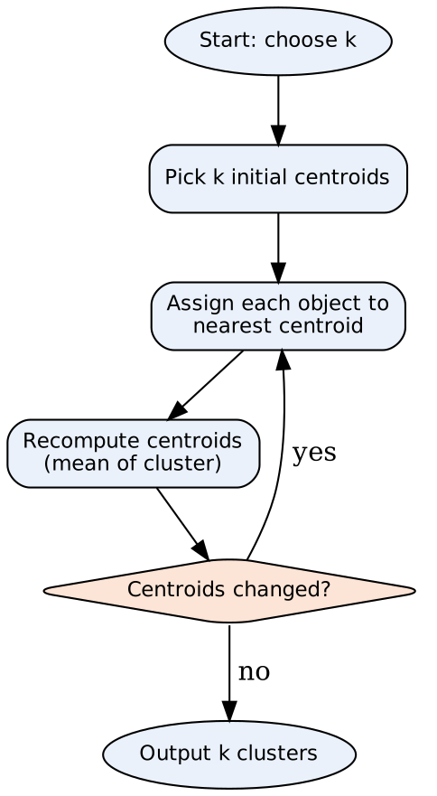
- Choose k / initial centroids: user input; random selection.
- Assign: distance calculation for every object.
- Recompute: move centroid to mean of assigned objects.
- Decision: loop until stable → output clusters.

2. Worked example (k = 2)
Given: {2, 3, 4, 10, 11, 12, 20, 25, 30}; initial means $m_{1}=2$, $m_{2}=4$.
Iteration | Means used | Cluster 1 | Cluster 2 | New means
1 | 2, 4 | {2, 3} | {4, 10, 11, 12, 20, 25, 30} | 2.5, 16
2 | 2.5, 16 | {2, 3, 4} | {10, 11, 12, 20, 25, 30} | 3, 18
3 | 3, 18 | {2, 3, 4, 10} | {11, 12, 20, 25, 30} | 4.75, 19.6
4 | 4.75, 19.6 | {2, 3, 4, 10, 11, 12} | {20, 25, 30} | 7, 25
5 | 7, 25 | {2, 3, 4, 10, 11, 12} | {20, 25, 30} | 7, 25 (no change)
Final answer: $C_{1}$ = {2, 3, 4, 10, 11, 12} (mean 7), $C_{2}$ = {20, 25, 30} (mean 25). (Tie at 3 with means 2 and 4 is assigned to the first cluster.)

3. K-Medoids (PAM — Partitioning Around Medoids)
- Select k representative objects (medoids) — actual data points.
- Assign each remaining object to the nearest medoid.
- For each medoid m and non-medoid o: swap them and compute total cost S.
- If S < 0 (cost decreases), keep the swap.
- Repeat until no improvement.
- More robust to outliers than K-means (medoid is a real point, not a mean).

4. CLARA (Clustering LARge Applications)
- Applies PAM on random samples of the data and picks the best set of medoids → scales to large datasets.

5. Text clustering with K-means (notes code idea)
TF-IDF vectorise documents → (optional) TruncatedSVD to reduce dimensions → KMeans(n_clusters=k).fit_predict(X) → print documents per cluster.

Advantages / Disadvantages
Advantages | Disadvantages
Simple, easy to implement | k must be known in advance
Efficient: O(n·k·t) | Sensitive to initial centroids
Works well for large document sets | Sensitive to outliers (use K-medoids)
Clusters easy to interpret (centroid terms) | Only spherical, similar-size clusters

Conclusion
Partitioning algorithms (K-means, K-medoids, CLARA) split data into k exclusive clusters by iteratively assigning objects to the nearest centre and updating centres until the squared error stops decreasing.
Memory trick: K-means loop = “A-U-R”: Assign → Update → Repeat. “Means for speed, Medoids for outliers, CLARA for large data.”

Last-Minute Revision Sheet — Unit 2
Topic | Key point to write
Classification vs clustering | Supervised + predefined labels vs unsupervised + discovered groups
Clustering for classification | Cluster-then-label; semi-supervised; clusters as features
Clustering types | PHD-MG: Partitioning, Hierarchical, Density, Model, Grid
K-means | Choose k → assign to nearest mean → update means → repeat; $E=∑∑∥p−m_{i}∥^{2}$
K-medoids / CLARA | Real points as centres (robust to outliers) / PAM on samples (large data)
Naïve Bayes | $c=argmaxP\left(c\right)∏P\left(t_{k}ǀc\right)$; add-one: $\left(T_{ct}+1\right)/\left(∑T_{ct′}+ǀVǀ\right)$
NB applications | Spam filtering, sentiment, topic categorisation, language ID, intent detection
KNN | Lazy, non-parametric; cosine on TF-IDF; majority (or weighted) vote of k neighbours
Single link | $d=min$; update matrix with min; dendrogram; chaining effect
Linkage types | Single (MIN), Complete (MAX), Average (MEAN), Centroid, Ward (min SSE)
GMM | $p\left(x\right)=∑π_{k}N\left(xǀμ_{k},Σ_{k}\right)$; EM: E = responsibilities, M = update; soft clusters
Contiguity hypothesis | Same-class docs form contiguous, non-overlapping regions → Rocchio, KNN, SVM
Mnemonics: Teacher vs Crowd (2.1) · PHD-MG (2.2) · PPM + smoothing (2.3) · MIN/MAX/MEAN (2.4, 2.7) · “Tell me your neighbours” (2.5) · π-μ-Σ (2.6) · Birds of a feather (2.8) · A-U-R (2.9).

Assumptions & Gaps
- Unit mapping: Q3/Q4 of every paper mapped to Unit 2 = syllabus Unit IV (Text Classification and Text Clustering).
- ⚠ Not found in your materials: 2.8 contiguity hypothesis (the notes cover hyperplane/kernel classification but never state the hypothesis); worked numerical for 2.4 (notes give the steps but no solved example — example data was chosen by me); formulas for centroid/Ward linkage in 2.7; density/grid-based types in 2.2.
- 2.3 merges N23’s “applications of naïve Bayes classifier” with the later “algorithm and its application” wording — the answer covers both.
- 2.9 asked once for 10 marks; the notes’ K-means worked example was not fully legible in the OCR, so a standard 1-D example is used.
- Citations give PDF page numbers of IR Sem7.pdf (two printed pages per PDF page) and section numbers printed in the notes.

